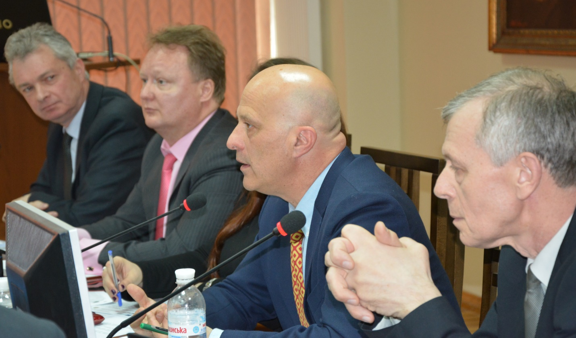

Brief overview on the achievements of the RETHINKe Project meeting
- financed by European Union Commission through the TEMPUS Program -
Kharkov, Ukraine, March 23rd 2016.

The experience of the project implementation was shared by:
Antonio Castelbranco – Professor of the University of Lisbon; Coordinator of the TEMPO and INFINITY Projects
Serhiy Volodymyrovych Kolesnichenko - Vice Rector for International Activities,
Ihor Viktorovych Tochonov – Vice Rector for Financial and Scientific Activities of Donbas National Academy of Civil Engineering and Architecture;
Ievhen Ivanovych Zbykovski – Head of the Department of Chemical Technology of Fuel of Donetsk National Technical University.

Antonio Castelbranco’s main message was: the urgent need of creating and developing a useful common language within the European continent; namely, an ACADEMIC LANGUAGE that unifies all those who work with the academic credits, and in particular with the ECTS system.
Because above all, “our universities are here to be useful to our students, and to help ensure their employability,” emphasized Prof. Castelbranco, “and that means that we all need to be more connected, we all need to communicate more effectively, and in fact, these are the principal objectives of the RETHINKe Project.”

During the meeting, the colleagues from the Donbass universities willingly and openly shared their experience in TEMPUS «Rethink» project.
According to Serhiy Volodymyrovych Kolesnichenko, the main problems in the project implementation have been: low level of students' knowledge of English (minimum acceptable level B1), the coordination of credits between higher educational institutions and the inability to issue Ukrainian diplomas to foreign students.

Although the main directions of the meeting were Environmental Engineering, Construction, Architecture and Urban Development, all the departments of the university actively participated and showed interest in the project.
Ihor Viktorovych Tochonov stressed particular significance and importance of the Department of Foreign Languages, emphasizing interdisciplinary connections and the need to introduce courses in English.
Ievhen Ivanovych Zbykovski spoke about the importance of understanding the obligations assumed by the project partners and a real example of the participation of students of Donetsk National Technical University in the double degree project.
After the meeting, Head of International Relations and Education - Natalya Bibik encouraged the participants of the University to analyze the possibility of establishing double degrees in the departments and to submit their proposals to the center for further implementation based on the received information.

